1)Docker 2 assignment
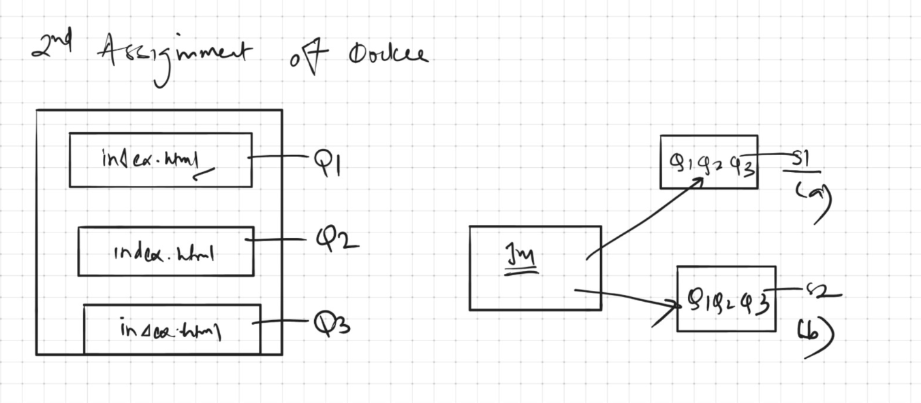

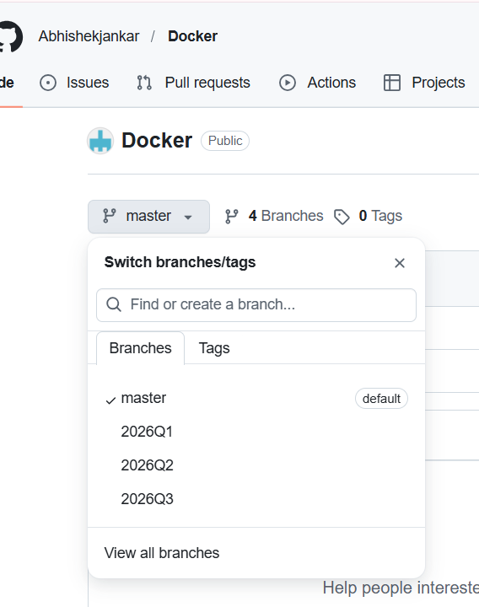

3)Jenkinsfile
pipeline{

agent any

environment {
REPO_URL = "https://github.com/Abhishekjankar/Docker.git"
}

stages {

stage("deploying on slave-1"){

agent{
label "slave-1"
}

stages{
stage("cloning branches"){
steps{

dir("Q1"){
git branch: "2026Q1", url:"${REPO_URL}"

}
dir("Q2"){
git branch: "2026Q2", url:"${REPO_URL}"
}

dir("Q3"){
git branch: "2026Q3", url:"${REPO_URL}"

}
}

}

stage("deploying"){
steps{

sh'''

sudo docker rm -f c1 c2 c3 || true
sudo docker run -dp 8081:80 --name c1 httpd
sudo docker cp Q1/index.html c1:/usr/local/apache2/htdocs/
sudo docker exec c1 chmod -R 777 /usr/local/apache2/htdocs/index.html

sudo docker run -dp 8082:80 --name c2 httpd
sudo docker cp Q2/index.html c2:/usr/local/apache2/htdocs/
sudo docker exec c2 chmod -R 777 /usr/local/apache2/htdocs/index.html

sudo docker run -dp 8083:80 --name c3 httpd
sudo docker cp Q3/index.html c3:/usr/local/apache2/htdocs/
sudo docker exec c3 chmod -R 777 /usr/local/apache2/htdocs/index.html

'''

}

}

}

}

stage("deploying on slave-2"){

agent{
label "slave-2"
}

stages{
stage("cloning branches"){
steps{

dir("Q1"){
git branch: "2026Q1", url:"${REPO_URL}"

}
dir("Q2"){
git branch: "2026Q2", url:"${REPO_URL}"
}

dir("Q3"){
git branch: "2026Q3", url:"${REPO_URL}"

}
}

}

stage("deploying"){
steps{

sh'''

sudo docker rm -f c1 c2 c3 || true
sudo docker run -dp 8081:80 --name c1 httpd
sudo docker cp Q1/index.html c1:/usr/local/apache2/htdocs/
sudo docker exec c1 chmod -R 777 /usr/local/apache2/htdocs/index.html

sudo docker run -dp 8082:80 --name c2 httpd
sudo docker cp Q2/index.html c2:/usr/local/apache2/htdocs/
sudo docker exec c2 chmod -R 777 /usr/local/apache2/htdocs/index.html

sudo docker run -dp 8083:80 --name c3 httpd
sudo docker cp Q3/index.html c3:/usr/local/apache2/htdocs/
sudo docker exec c3 chmod -R 777 /usr/local/apache2/htdocs/index.html

'''

}

}

}
}
}
}
4)webpages on slave-1






5)webpages on slave-2






